**WEEK 3: Assignment**

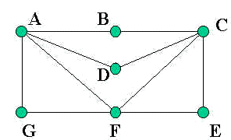

1. For the above graph find the distance between A to all the vertices

Answer: Basically, a graph is a pair of sets (V, E), where V is the set of vertices and E is the set of edges, connecting the pairs of vertices.

V={A,B,C,D,E,F,G}; the distance between A to all the vertices will be:

d(A,A)=0

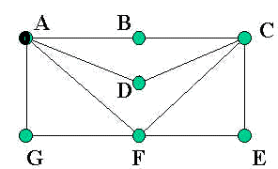

d(A,B)=1

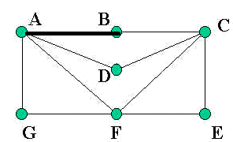

d(A,C)=2

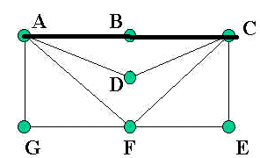

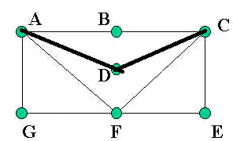

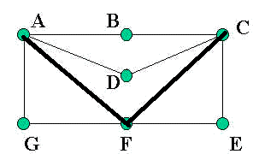

d(A,D)=1

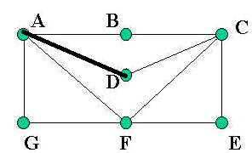

d(A,E)=2

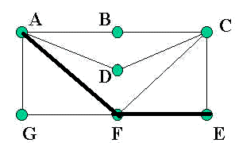

d(A,F)=1

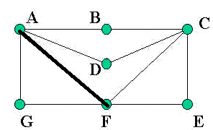

d(A,G)=1

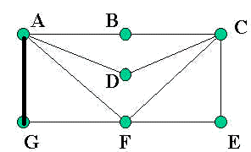

1. For the above graph Calculate the eccentricity of each vertex.



Answer: The maximum distance between a vertex to all other vertices is considered as the eccentricity of vertex. Denoted by− e(V) So, the eccentricity of each vertex for the graph:

e(A)=2, e(A)={{AB},{AG},{AD},{AF}}

e(B)=2,

e(B)={{BA},{BC}}

e(C)=2,

e(C)={{CB},{CD},{CF},{CE}}

e(D)=2,

e(D)={{DA},{DC}}

e(E)=2,

e(E)={{EC},{EF}}

e(F)=2,

e(F)={{FE},{FC},{FA},{FG}}

e(G)=2,

e(G)={{GF},{GA}}

1. For the above graph Calculate the radius of each vertex.

Answer: The minimum eccentricity from all the vertices is considered as the radius of the Graph. Denoted by − r(G). So, the radius of each vertex:

r(A)=2

r(B)=2

r(C)=2

r(D)=2

r(E)=2

r(F)=2

r(G)=2

The minimum eccentricity from all the vertices is 2 . So ,r(G)=2; radius=2.

1. For the above graph Calculate the diameter of each vertex.

Answer: The maximum eccentricity from all the vertices is considered as the diameter of the Graph G. The maximum among all the distances between a vertex to all other vertices is considered as the diameter of the Graph G. Denoted by− d(G). So, the diameter of each vertex:

e(A)=2

e(B)=2

e(C)=2

e(D)=2

e(E)=2

e(F)=2

e(G)=2

The maximum eccentricity from all the vertices is 2;diameter=2.

1. For the above graph Calculate the Circumference and Girth.

Answer: The number of edges in the longest cycle of ‘G’ is called as the circumference of ‘G’. So, the circumference of given graph will be 6.

(A-B-C-D-E-F-G-A)

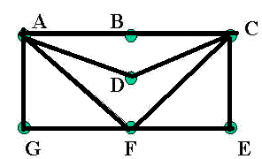

Or

(E-F-G-A-D-C-B-E).



The number of edges in the shortest cycle of ‘G’ is called its Girth. Denoted by− g(G). So, the girth of the given graph will be: 3.

(A-G-F-A)

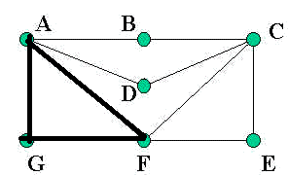

OR

(C-E-F-C)

